**Exception Handling**

class Person {

String name;

int age;

Person(this.name, this.age) {

if (age <= 0) {

throw ArgumentError('Age must be a positive integer.');

}

}

void greet() {

print('Hello, my name is $name and I am $age years old.');

}

}

void main() {

try {

var person1 = Person('Alice', 30);

print('Name: ${person1.name}');

print('Age: ${person1.age}');

person1.greet();

var person2 = Person('Bob', 25);

person2.greet();

// Let's try creating a person with invalid age

var person3 = Person('Charlie', -5);

person3.greet(); // This line won't execute due to the exception thrown

} catch (e) {

print('Exception occurred: $e');

}

}

**Output:**

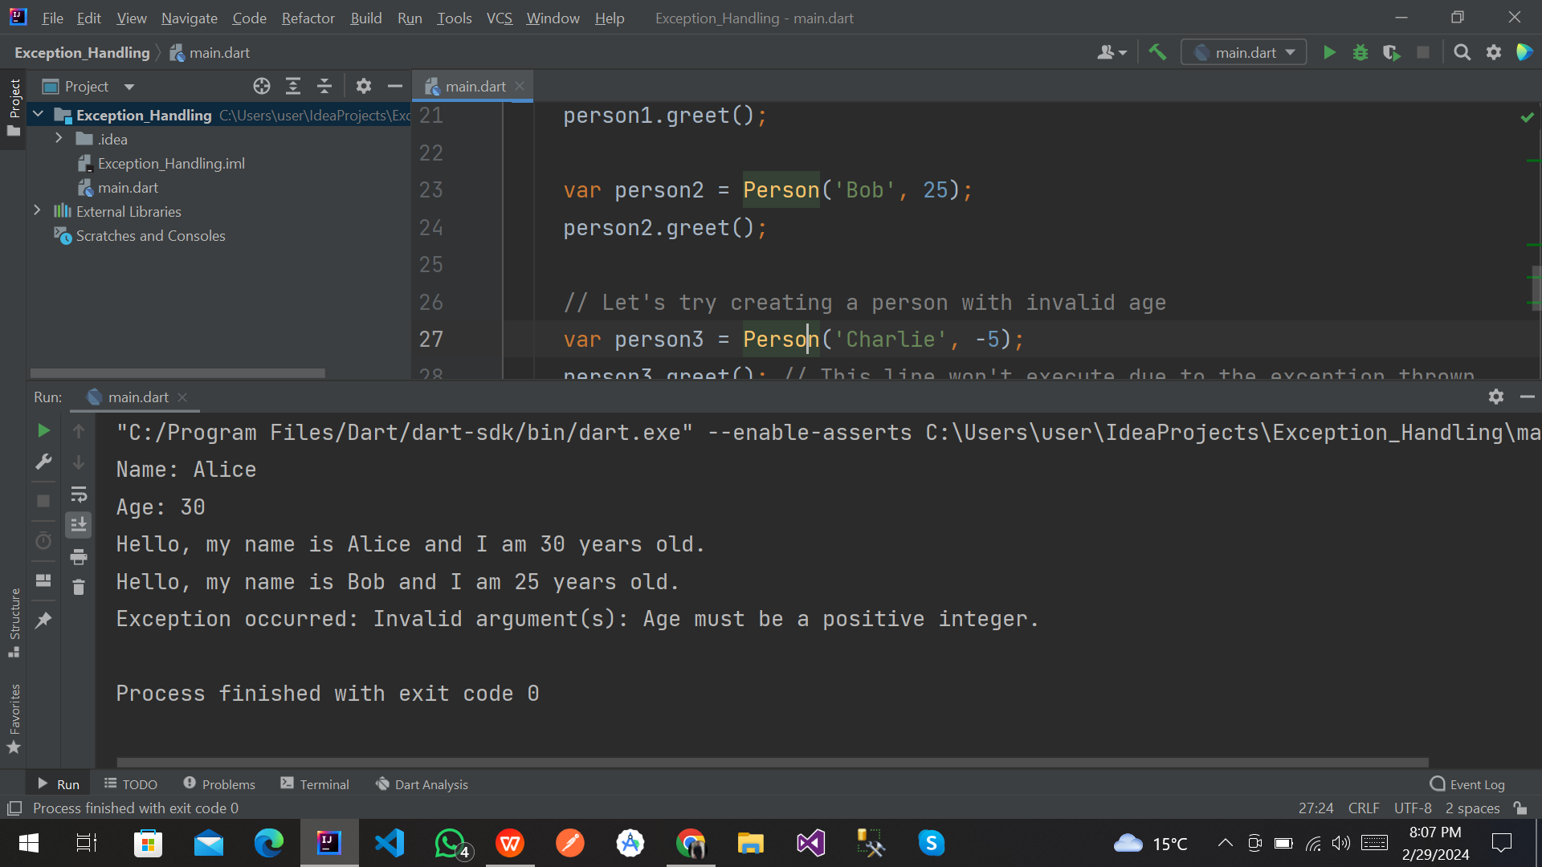

**END**